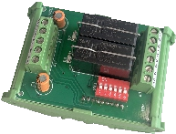
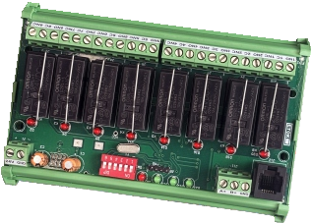
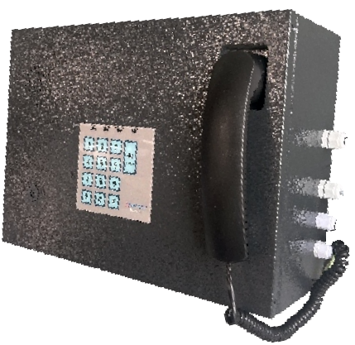


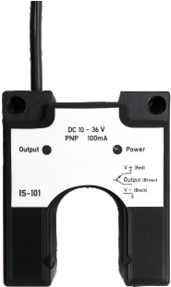


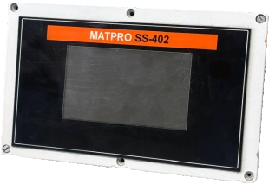







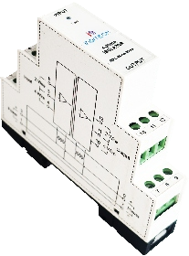




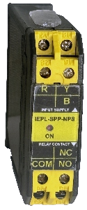
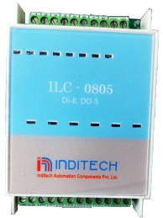
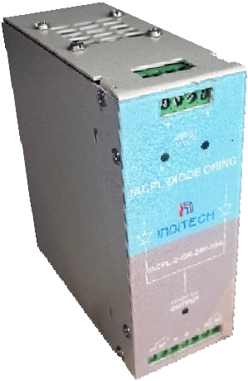
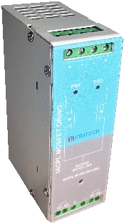
MODBUS I/O BOARD
Operating voltage Numbers of channel Communication Baud rate
Model: IACPL-2CH-DO-MOD-12V/24V
IACPL-8CH-DO-MOD-12V/24V
12VDC/24VDC + 20%
2/8
-
RS 485, Modbus-RTU User configurable. 2 channel, digital output /RS 485 module
8 channel, digital output /RS 485 module
TELE - PA SYSTEM
Model Operating voltage
Audio output power
Keypad Connectivity
TELEPA-25 210 to 240VAC 50Hz
25W RMS
12-Button DTMF Keypad (0-9, *, #) & hands free button. RJ-10, RJ11, wire Terminals.
U-TYPE SENSOR (P-TYPE, N-TYPE)
Model Operating voltage Gap/ range Output current Protection
Model: IACPL-IS-100-P
IACPL-IS-101-N
Photoelectrical sensor 10 to 36VDC
30mm
100mA
Reverse polarity, short circuit and transients. P OUTPUT
N OUTPUT
CUSTOMIZE HMI
Model Operating voltage
Encoder or any other input Analog input/output Digital input/output Display type
Communication
HMI
110 OR 230VDC
As per requirement As per requirement 5”/7” HMI with 800x480 pixel Capacitive touch
Ethernet, Modbus, USB, R422
Systems Pvt. Ltd.
Location
Sr. no 6/3A, Deshmukhwadi / Deshmukhnagar, Shivane, NDA Road, Pune - 411023, Maharashtra, India.
Email
akshay.gaykar@inditechsystems.com suresh.nene@inditechsystems.com
Inditech Automation
Phone
+91 92250 98649
+91 77740 08790
www.inditechautomation.com
Follow Us :
A U T O M A T I O N S Y S T E M S
AUTOMATION COMPONENTS
DIODE ORING
Input Voltage drop across device
Model: IACPL DOR-24 V-XX A IACPL DOR-48V-XX A IACPL DOR-110V-XX A
IACPL DOR-220V-XX A
Two nos. DC voltage Inputs
<0.85V Max at full load
Voltage: 24VDC , Current:5A,10A,20A,40A,63A Voltage: 48VDC , Current:5A,10A,20A,40A,63A Voltage: 110VDC , Current:5A,10A,20A,40A,63A Voltage: 220VDC , Current:5A,10A,20A,40A,63A
MOSFET ORING
Input
Voltage drop across device Mounting
Model: IACPL MOR-24 V-XX A
Two nos. DC voltage Inputs
<0.2V Max at full load for 24VDC/48VDC.
<0.4V Max at full load for 110VDC/220VDC. Din rail
Voltage: 24VDC, Current:10A,20A
4-20mA SIGNAL ISOLATOR
Input /Output Isolation type Accuracy
Model : IACPL-ISO-4-20mA-01
IACPL-ISO-4-20mA-02
4 to 20mA DC Optical and Galvanic
±0.1%
4-20mA DC / Voltage: 24VDC
4-20mA DC / Voltage: 230VAC
Type
DEDICATED LOGIC CONTROLLER (DLC)
PLC MODULE
Digital Input Voltage Output Load (resistive) Isolation type Mounting
Model: IACPL-DLC-8I5O
24VDC
Max. 230 VAC / 7Amp. Optical and Galvanic Din rail
8 Opto-inputs and 5 relays logic controller
Operating Voltage :24VDC.
SINGLE PHASE PREVENTER
Operating Voltage Phase failure trip accuracy
Model : IACPL-SPP-01
IACPL-SPP-02
160 to 500 VAC
< 270VAC
± 2%
Monitor phase failure and phase imbalance Monitor phase failure, imbalance, sequence
Customize HMI

